COURSEWORK ASSIGNMENT

Module Title: Operating Systems and Computer Networks | Module Code: 5WCM2010
Assignment Title: Network Design | Individual Assignment
Tutor: Kufreh Sampson | Internal Moderator: Azita Pourghasem

Student ID Number ONLY: | Year Code:
23016710 | 2024-2025

Marks Awarded %: | Marks Awarded after Lateness Penalty applied %:
Penalties for Late Submissions
- Late submission of any item of coursework for each day or part thereof (or for hard copy submission only, working day or part thereof) for up to five days after the published deadline, coursework relating to modules at Levels 0, 4, 5, 6 submitted late (including deferred coursework, but with the exception of referred coursework), will have the numeric grade reduced by 10 grade points until or unless the numeric grade reaches or is 40. Where the numeric grade awarded for the assessment is less than 40, no lateness penalty will be applied.
- Late submission of referred coursework will automatically be awarded a grade of zero (0).
- Coursework (including deferred coursework) submitted later than five days (five working days in the case of hard copy submission) after the published deadline will be awarded a grade of zero (0).
- Where genuine serious adverse circumstances apply, you may apply for an extension to the hand-in date, provided the extension is requested a reasonable period in advance of the deadline.
Please refer to your student handbook for details about the grading schemes used by the School when assessing your work. Guidance on assessment will also be given in the Module Guide.
Guidance on avoiding academic assessment offences such as plagiarism and collusion is given at this URL: http://www.studynet.herts.ac.uk/ptl/common/LIS.nsf/lis/citing_menu

Table of Contents:

- Introduction………………………………………………………………………………………………………………03
- Overview of the Network Design
- Marks awarded for

- Backbone Structure Design…………………………………………………………………………………………03
- Core Layer Design
- Distribution Layer Design
- Explanation

- LAN Design………………………………………………………………………………………………………………04
- Distribution Layer
- Access Layer
  - Main Building
  - Learning Resource Centre
  - Yorkon Building(Server Farm)

- Subnetting & IP Address Allocation………………………………………………………………………………04
- What is Subnetting?
- IP Address Allocation for VLANs
- Understanding IP Addresses and Their Usage
- IP Addressing in the Assignment
- VLAN Subnet Assignments

- Network Devices & Cabling Justification………………………………………………………………………06
- Core Layer Devices (Routers, Firewalls)
- Distribution Layer Devices (Layer 2 Switches, Servers)
- Access Layer Devices (Layer 2 Switches, Workstations)
- Cable Selection (Crossover vs. Straight-Through)

- Wireless Network for Visitors, Students, and Staff…………………………………………………………07
- Assumptions for Wireless Users
- VLAN and Subnet Allocation for Wireless Devices
- DHCP Implementation

- Self-Evaluation & Recommendations………………………………………………………………………….08
- Strengths of the Network Design
- Limitations and Areas for Improvement

- References……………………………………………………………………………………………………………….09

Overview of the Network Design:
Based on the given scenario, a comprehensive network design is required to illustrate the backbone structure. Where necessary, the design will be extended with detailed LAN layouts based on the floor plans provided.

Marks awarded for:
• Backbone Design: appropriate backbone structure is chosen; proper network devices are used
for the interconnection of various network sections; justifications are made for the design
choices.
• Design of LANs: appropriate LAN topology is determined; proper network devices are used to
allow the workstations to access online; justifications are made for the design choices.
• IP Address Allocation: effective and efficient use of the given IP address; subnets are divided
properly to satisfy the requirements; DHCP server is placed properly with an address pool;
calculation process is shown; alternative IP address scheme is considered where appropriate.
• Self-Evaluation: both the advantages and the limitations of the devised solution are analyzed;
recommendations are given for the future improvements; research evidence is provided where
necessary.
• Quality of Report: academic writing; presentation of the written work.

Backbone Structure Design:

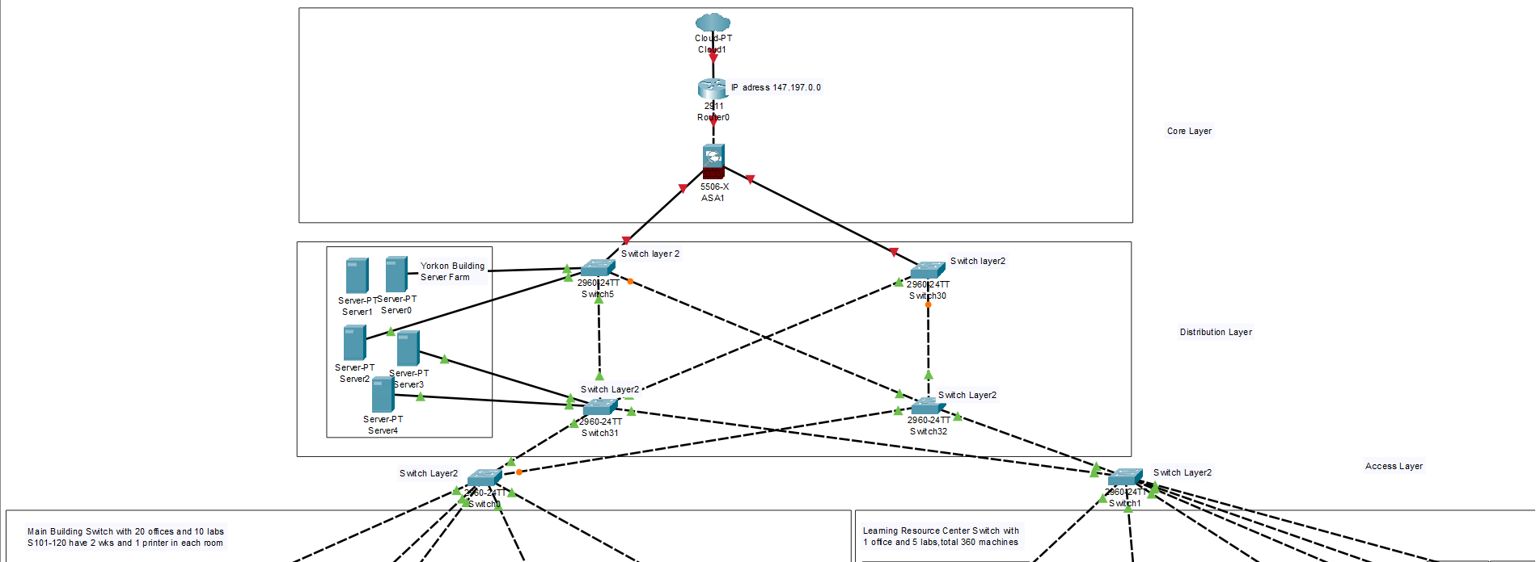

Explanation:
The image represents a hierarchical network topology with three layers. The Core Layer includes a cloud, a router with IP 147.197.0.0, and a firewall (ASA) for external connectivity. The Distribution Layer consists of Layer 2 switches aggregating traffic and a server farm (Yorkon Building) with multiple servers. The Access Layer features switches connecting end devices, including a Main Building Switch serving 20 offices and 10 labs (each with 2 workstations and 1 printer) and a Learning Resource Center Switch supporting 1 office and 5 labs with 350 machines. This three-tier model enhances scalability, redundancy, and management.

LAN Designs of Main Building and Learning Resource Centre:

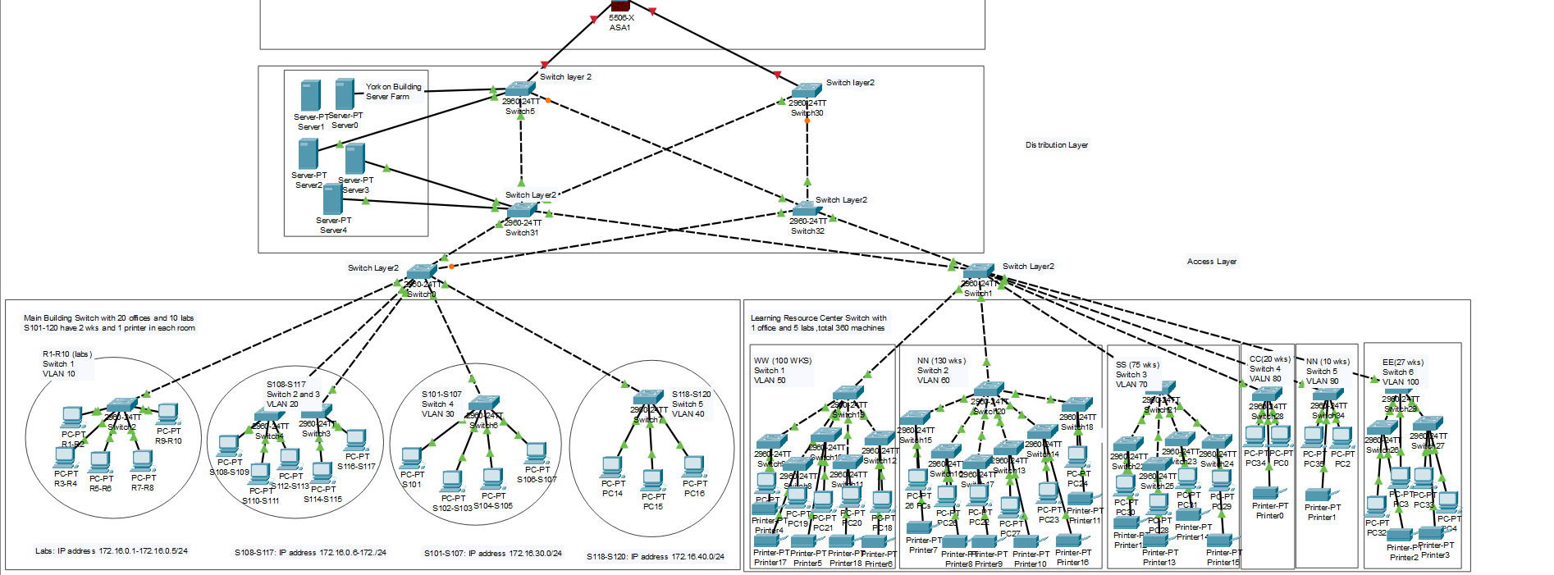

Explanation:
The updated hierarchical network topology consists of a Core Layer with a router (IP: 147.197.0.0) connected to a firewall (ASA) for external connectivity, a Distribution Layer with Layer 2 switches aggregating traffic and linking to a server farm (Yorkon Building) hosting multiple servers, and an Access Layer featuring multiple switches implementing VLAN segmentation with assigned IP ranges (e.g., 172.16.0.0/24). The Main Building Switch serves 20 offices and 10 labs, each with workstations and printers, while the Learning Resource Center Switch connects 1 office and 5 labs, supporting 350 machines. VLANs enhance traffic management by segmenting network devices, ensuring efficient connectivity. This refined three-tier topology optimizes scalability, redundancy, and structured device allocation, making it ideal for enterprise environments.

Subnetting Details:

What is Subnetting?
Subnetting divides a large network into smaller, more manageable sub-networks. For large organizations or geographically dispersed systems, subnetting ensures efficient network management by segmenting networks into smaller groups interconnected by routers.
The university has acquired a Class B network address (147.197.0.0). Based on the network’s device requirements, an optimized IP address management plan has been devised.



IP Address Allocation for VLANs:

Main Building
- Labs (Switch 1 - VLAN 10): 172.16.10.0/24
- Rooms S108-S117 (Switch 2 & 3 - VLAN 20): 172.16.20.0/24
- Rooms S10-S107 (Switch 4 - VLAN 30): 172.16.30.0/24
- Rooms S118-S120 (Switch 5 - VLAN 40): 172.16.40.0/24
Learning Resource Centre
- WW (Switch 1 - VLAN 50): 172.16.50.0/24
- NN (Switch 2 - VLAN 60): 172.16.60.0/24
- SS (Switch 3 - VLAN 70): 172.16.70.0/24
- CC (Switch 4 - VLAN 80): 172.16.80.0/24
- NN (Switch 5 - VLAN 90): 172.16.90.0/24
- EE (Switch 6 - VLAN 100): 172.16.100.0/24
Visitors, Students, and Staff (Mobile Devices)
- Visitors (VLAN 110): 172.16.110.0/24
- Students (VLAN 120): 172.16.120.0/23 (Supports 510 usable hosts)
- Staff (VLAN 130): 172.16.130.0/24
- IoT & Security Devices (VLAN 140): 172.16.140.0/24

Understanding IP Addresses and Their Usage:
Before diving into the assignment requirements, it's essential to understand what an IP Address is and the difference between Public and Private IP Addresses.
A Public IP Address is assigned by an Internet Service Provider (ISP) and is globally routable, allowing devices to communicate over the internet. In contrast, Private IP Addresses are used internally within organizations and are not directly accessible from the internet. Instead, they rely on Network Address Translation (NAT) to connect to public networks, ensuring both security and efficient IP address allocation.

IP Addressing in the Assignment:
Now, let's discuss the assignment requirements concerning IP addressing. The university was assigned the public Class B IP address 147.197.0.0, which has been subnetted into /24 subnets, each supporting 254 usable hosts.

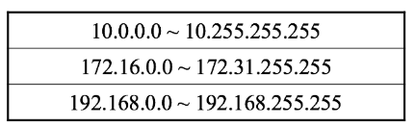

NAT (Network Address Translation) is the protocol that enables hosts on private networks to communicate with hosts on the Internet. NAT router has an external valid public IP address and internal private IP address. IP addresses (and possibly port numbers) of IP datagram are replaced at the boundary of a private network (i.e. NAT device).
We were given the Class B network (147.197.0.0) which was a public IP address. Rather than using a public IP range, we should use private addresses.

To achieve efficient network segmentation and organization, we subnetted the assigned Class B network into /24 subnets, each providing 254 usable hosts (out of 256 total addresses, accounting for network and broadcast addresses). Every VLAN is allocated a separate /24 subnet, ensuring structured segmentation and optimal resource allocation.
Furthermore, additional VLANs and subnets have been designated for DHCP-based dynamic IP addressing, facilitating scalability and efficient resource management while ensuring seamless network expansion as required.

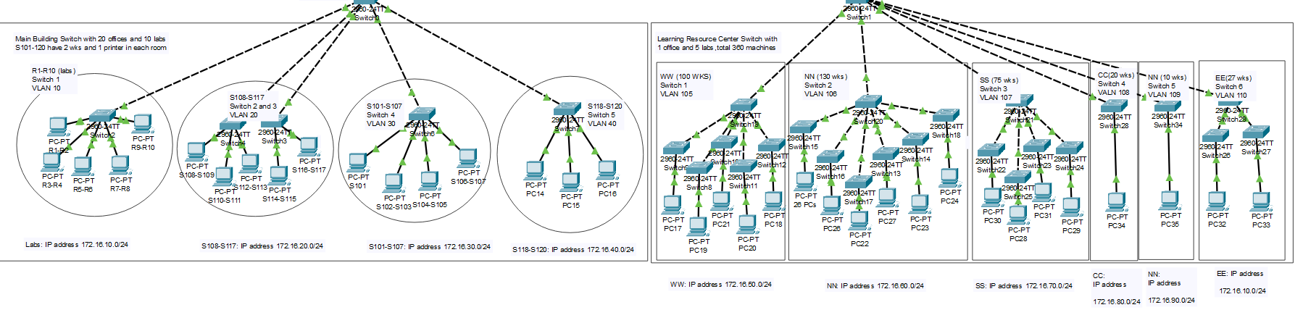
Justifications :

In the core layer:
Devices used:
- Cloud PT (ISP) is used to simulate an internet service provider, ensuring external network connectivity.
- A router is deployed in the core layer to manage data transmission, ensuring continuous network operation and providing an alternative path for data in case of a link failure.
- Firewall is implemented at the core layer to provide internal and external network security. The firewall prevents unauthorized access, regulates network traffic, and enhances both device-level and network-level protection.
Cables selection:
- ISP connects to the router through straight through straight cable because straight through cable is used for connecting different devices with each other.
- Router connects to the firewall through cross over cable because cross over is used to connect same devices with each other.

In the distribution layer:
Devices used:
- Servers from Yorkon Building relates to the layer 2 switches because it provides functionality for other programs or devices called "clients" (workstations, labs, etc.).
- Layer 2 switches (Cisco 2960-24TT) are utilized in the access layer because they:
- Are cost-effective compared to Layer 3 switches
- Provide fast and reliable Ethernet connectivity
- Use MAC address-based switching for efficient data forwarding
- Ensure seamless connectivity between end devices (workstations, printers, etc.)

Cables selection:
- Switches of layer 2 connects to the firewall through straight through cable because straight through is used to connect different devices with each other.
- Servers from Yorkon Building connected to firewall through cross over cable because cross over is used to connect same devices with each other.

- Layer 2 switches connected to layer 2 switches through cross over cable because cross over is used to connect same devices with each other.

In the Access layer:
Devices used:
- Layer 2 switches (Cisco 2960-24TT) are utilized in the access layer because they:
- Are cost-effective compared to Layer 2 switches
- Provide fast and reliable Ethernet connectivity
- Use MAC address-based switching for efficient data forwarding
- Ensure seamless connectivity between end devices (workstations, printers, etc.)

Cables selection:
- Layer 2 switches connected to layer 2 switches through cross over cable because cross over is used to connect same devices with each other.
- Layer 2 switches connected to layer 2 switches through crossover cable because cross over is used to connect same devices with each other.
- The Access Layer consists of five switches connecting various labs and offices in the Main Building using Star Topology. And consists of 6 switches connecting various workstations in the Learning Resource Centre using Star Topology.
- Each switch connects multiple PCs and printers within its assigned VLAN.
- These Access Layer switches are uplinkeded to a Layer 2 switch, which handles VLAN communication.

Wireless Network for Visitors, Students, and Staff:

- Separate VLANs are assigned to wireless users to maintain network segmentation and security.
- Staff and students have credential-based access to the network.
- Visitors receive time-limited access with restricted internal resource permissions.

DHCP:
IP addresses can either be manually assigned or automatically allocated by a DHCP server. DHCP server manages an IP address pool (a.k.a. range) and allocate them to its client workstations.
DHCP provides configuration parameters to the clients, e.g. IP address, address mask, gateway address, DNS server, address, host name, etc.
Conventionally DHCP server has to be within the same subnet as its clients in order to function properly.

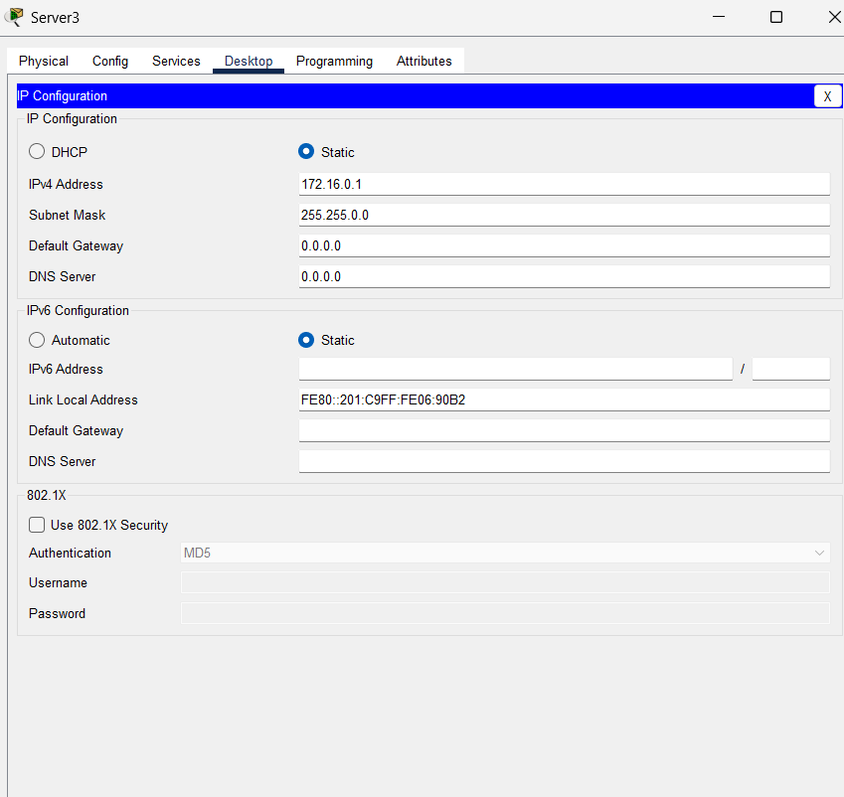

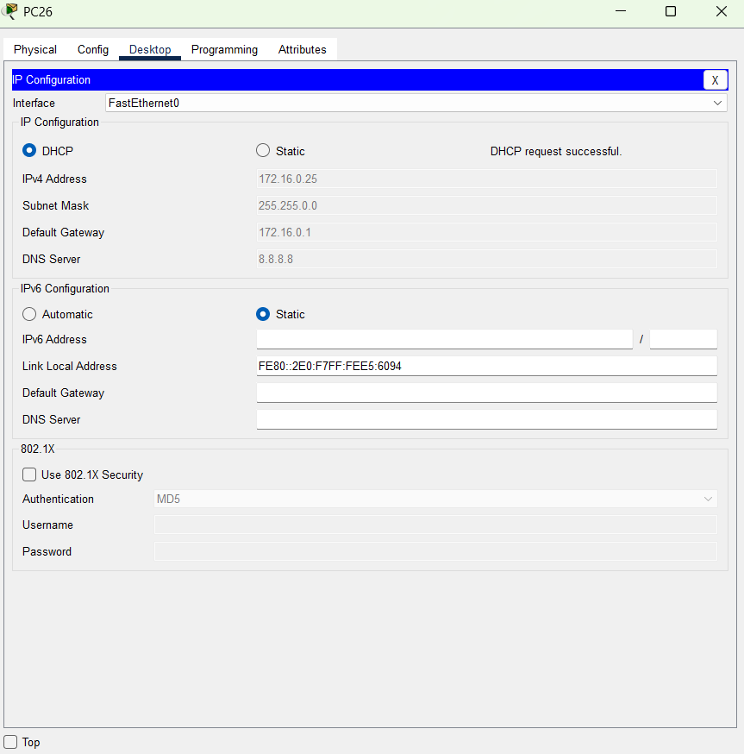

Self-Evaluation & Recommendations
  - Strengths of the Network Design
- Scalability: VLANs and subnetting enable seamless expansion.
- Security: Firewall and VLAN segmentation enhance protection.
- Efficiency: Optimized IP address allocation ensures smooth traffic flow.
- Manageability: Implemented a structured and scalable network design, with VLANs, DHCP, and subnetting, ensures efficient management, reduced administrative overhead, and streamlined security through centralized routing and firewall control.
- Affordability: Your network design is cost-effective, using Layer 2 switches, DHCP automation, and VLAN segmentation to minimize hardware and maintenance costs while ensuring efficiency.

  - Limitations and Areas for Improvement
- Availability /Redundancy: Implementing dual routers would enhance fault tolerance.
- Load Balancing: Introducing Layer 3 switches at the distribution layer could improve performance.
- Connecting the firewall to the server would have enhanced access security.

References:
- Firewall:
https://koreascience.kr/article/JAKO202121055727021.page (Google scholar)

- Usage of Server in Core Layer:
Download Tutorial 3. CCNA Course on Network Design.pdf (Pg# 5 Server Farm)

- Using Layer 2 Switches:
Download Tutorial 3. CCNA Course on Network Design.pdf (Pg# 15 Distribution Layer Routing)

- Using Server from Yorkon Building:
Unit 5.2 Network Devices( Server).
- VLANs:
Download Tutorial 4. VLAN.pdf

- Subnetting:
https://www.researchgate.net/profile/Shailesh-Sisat/publication/303298395_IP_Subnetting/links/573b7d3c08aea45ee84064f7/IP-Subnetting.pdf.

- NAT(Network addressing Translator):
Network security using NAT and NAPT

- DHCP:
Unit 3.3 IP Addresses
Setting up a Virtualized Environment with Networking Configurations

